# **Hardware Components**

## **Introduction**

Hardware components are the physical elements of a computer system that work together to perform various tasks. These components include processing units, memory, storage, input and output devices, and power supply units. Understanding the functions and characteristics of these components is essential for building and maintaining efficient computer systems.

## **1. Central Processing Unit (CPU)**

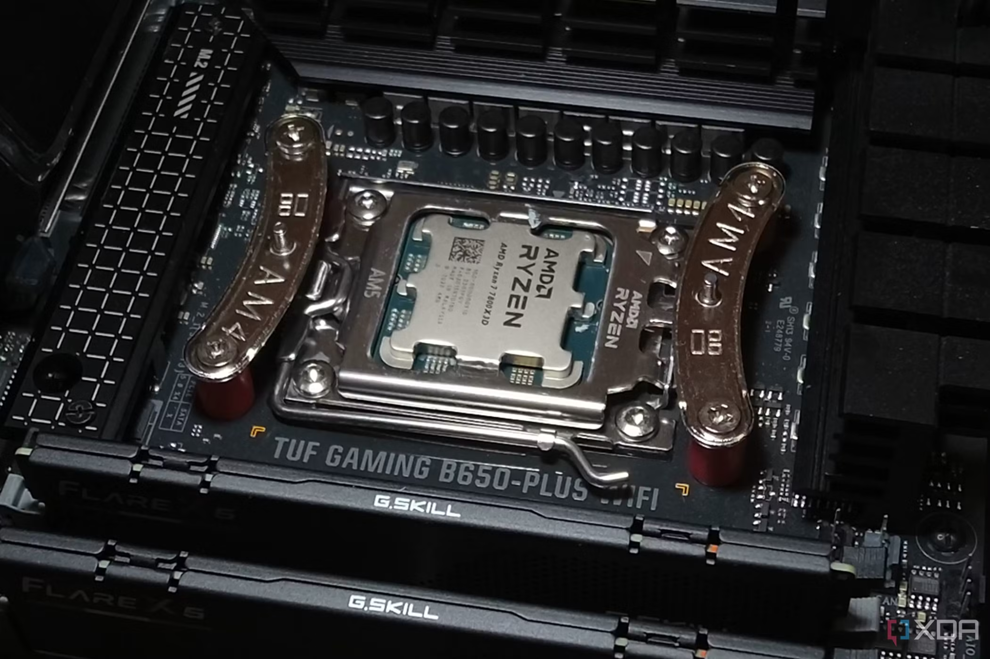

The Central Processing Unit (CPU) is the brain of the computer, responsible for executing instructions and processing data. It consists of three main parts:

* Control Unit (CU): Directs the operation of the processor.
* Arithmetic Logic Unit (ALU): Performs arithmetic and logical operations.
* Registers: Small storage areas that hold instructions and data for quick access.

Modern CPUs have multiple cores, allowing for parallel processing, and include cache memory to improve performance. Processors vary in speed (measured in GHz) and efficiency, impacting system performance.

## 

## **2. Memory (RAM & ROM)**

Memory is an essential component for storing and accessing data quickly.

### **Random Access Memory (RAM)**

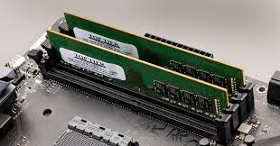

* Volatile memory that temporarily stores data for active processes.
* Allows for quick read/write access, enhancing system performance.
* Common types include DDR3, DDR4, and DDR5.
* More RAM improves multitasking and system responsiveness.

### 

### **Read-Only Memory (ROM)**

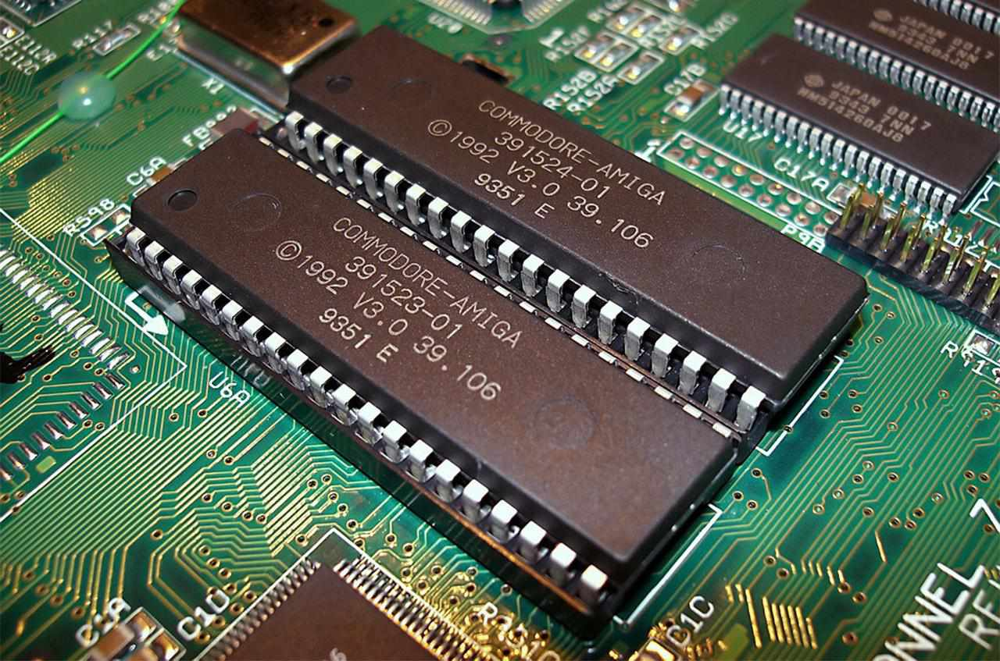

* Non-volatile memory that contains firmware and essential system instructions.
* Cannot be modified easily and is used for boot processes.
* Stores BIOS (Basic Input/Output System) or UEFI firmware.

## 

## **3. Storage Devices**

Storage devices retain data permanently or semi-permanently. They come in different types:

### 

### 

### 

### **Hard Disk Drive (HDD)**

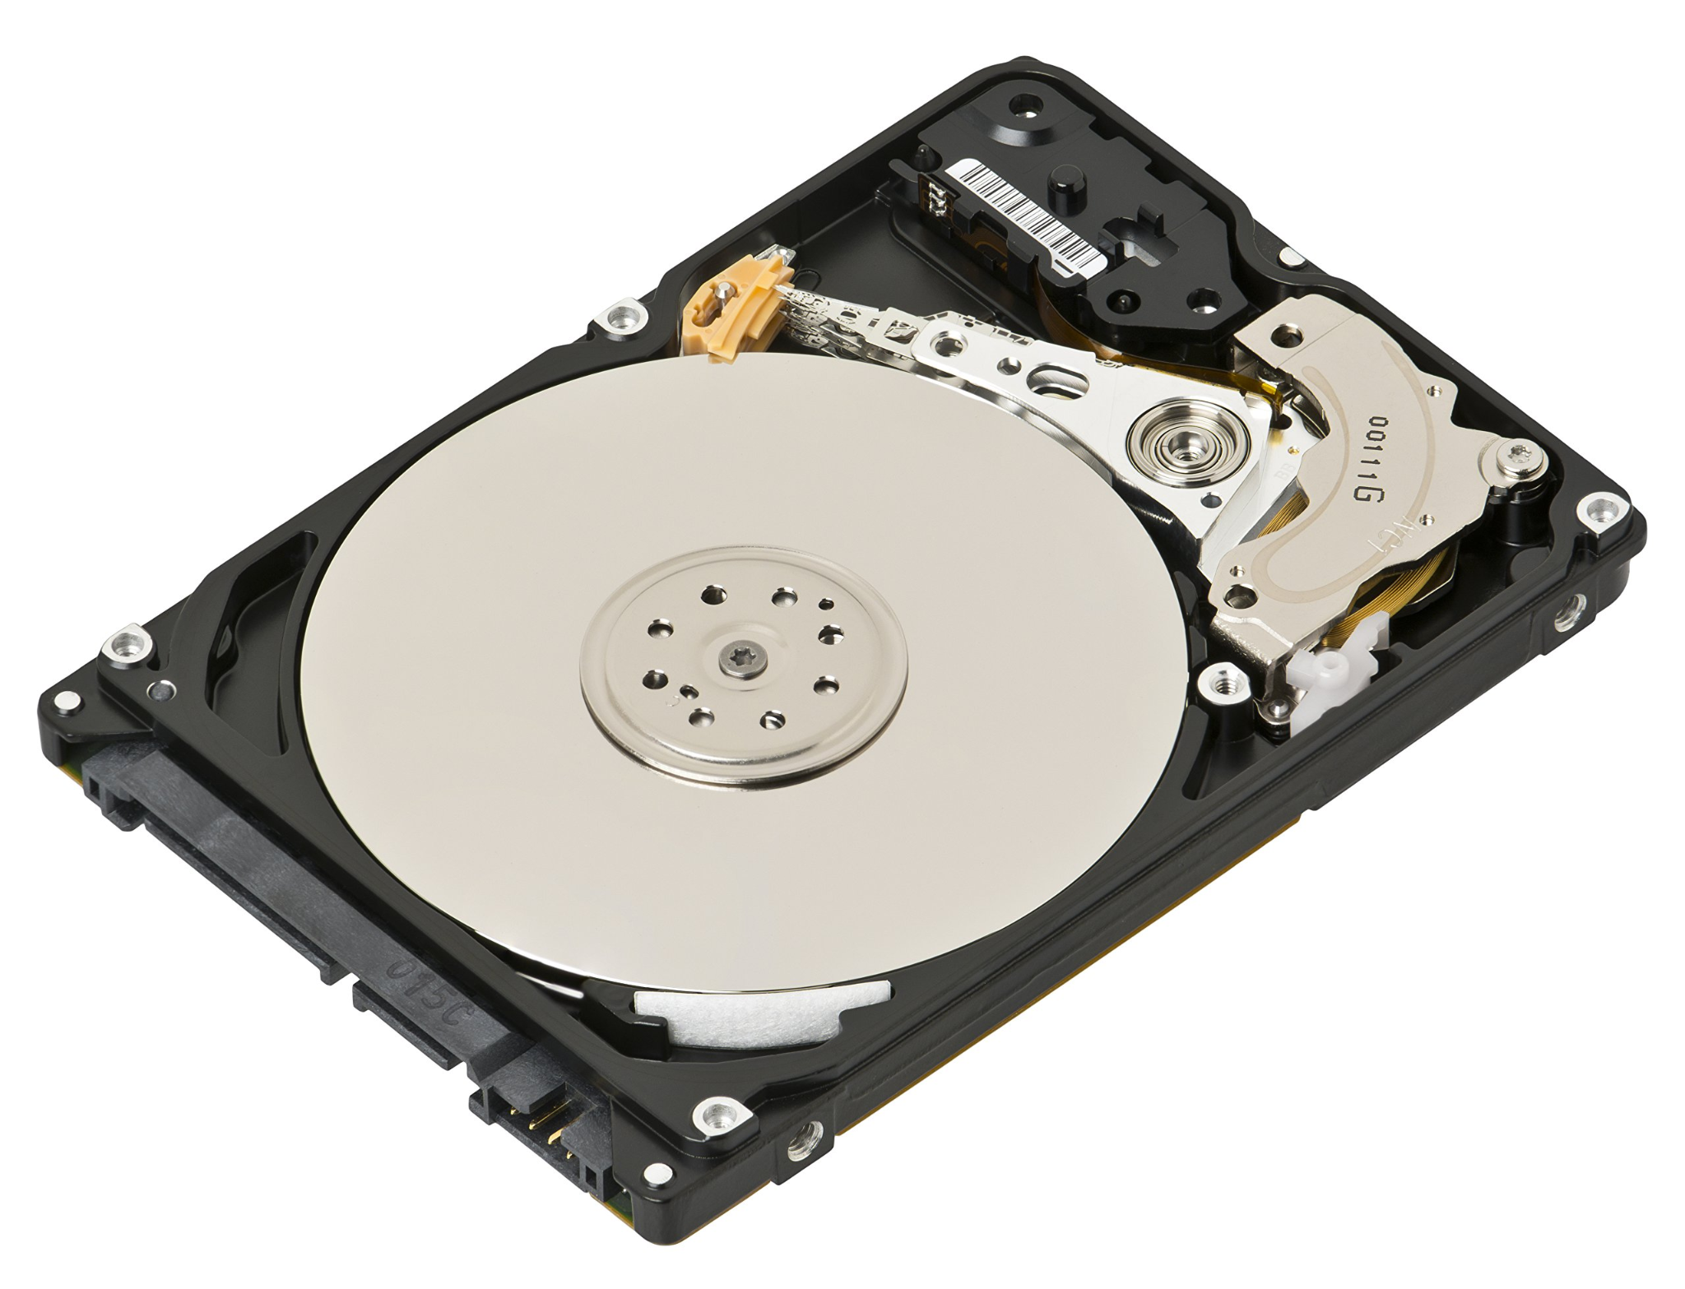

* Traditional magnetic storage with spinning disks (platters) and a read/write head.
* Provides large storage capacity at an affordable cost.
* Slower compared to modern alternatives but still widely used.

### **Solid-State Drive (SSD)**

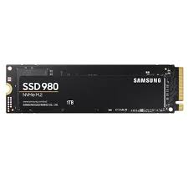

* Uses flash memory for faster read/write speeds compared to HDDs.
* More durable and energy-efficient but generally more expensive.
* Available in SATA, NVMe, and PCIe formats.

### **Other Storage Devices**

* USB Flash Drives: Portable and easy to use for data transfer.
* Memory Cards: Used in cameras, phones, and other portable devices.
* Cloud Storage: Online storage accessible via the internet.

## 

## **4. Motherboard**

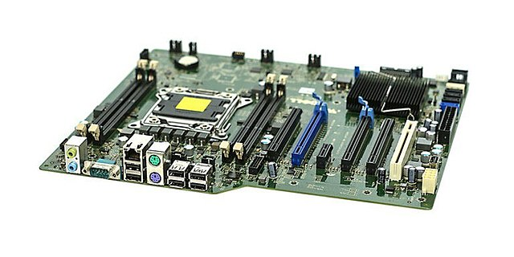

The motherboard is the main circuit board that connects all hardware components, including the CPU, memory, and storage. Key features include:

* Expansion slots for graphics cards, network cards, and other peripherals.
* Integrated ports for USB, audio, and networking.
* Power connectors and cooling systems to maintain performance.
* Chipset that determines system compatibility and performance.

## **5. Power Supply Unit (PSU)**

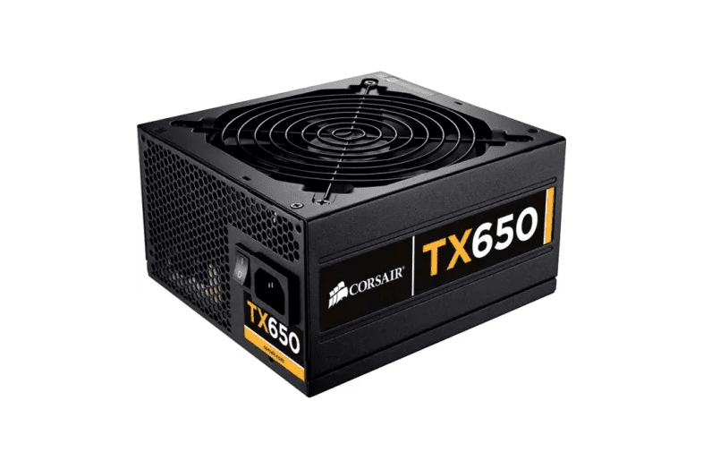

The Power Supply Unit (PSU) converts AC power from an outlet into DC power for computer components. Important aspects include:

* Wattage rating to ensure sufficient power supply.
* Efficiency rating (80 Plus standards) for energy-saving performance.
* Modular, semi-modular, and non-modular power supplies for better cable management.

## 

## 

## 

## 

## **6. Input and Output Devices**

These devices allow interaction with the computer.

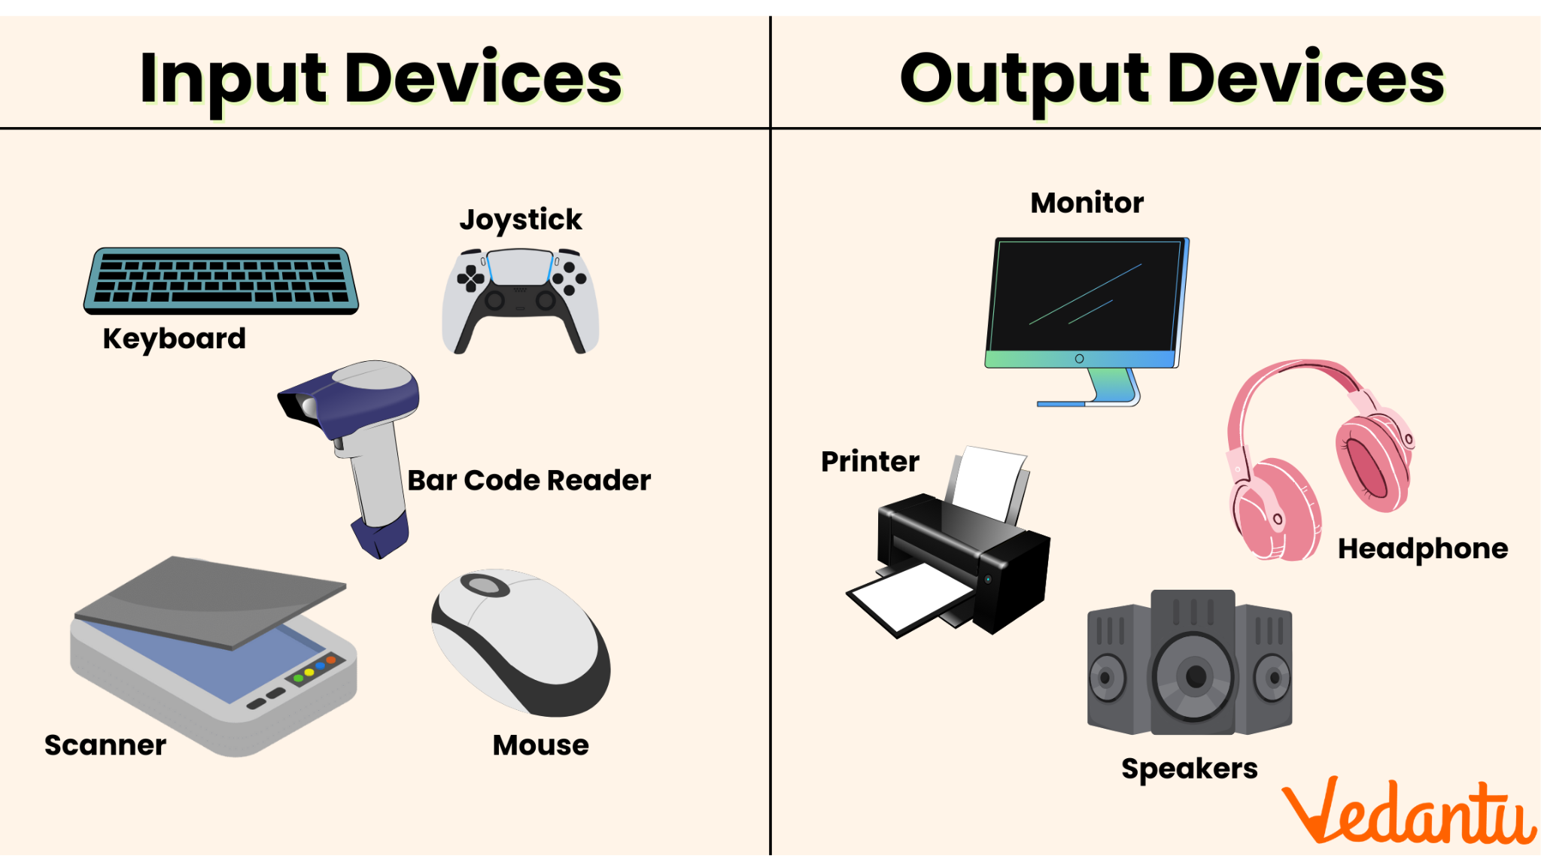

### **Input Devices**

* Keyboard: Used for typing and command input.
* Mouse: Provides point-and-click navigation.
* Scanner, Webcam, Microphone: Capture images, video, and sound.
* Touchscreens, Joysticks, Game Controllers: Specialized input for specific applications.

### **Output Devices**

* Monitor: Displays visual output; available in LCD, LED, and OLED technologies.
* Printers: Produce hard copies of digital documents; inkjet and laser types.
* Speakers & Headphones: Output audio signals.
* Projectors: Used for large-scale visual output.

## 

## **7. Graphics Processing Unit (GPU)**

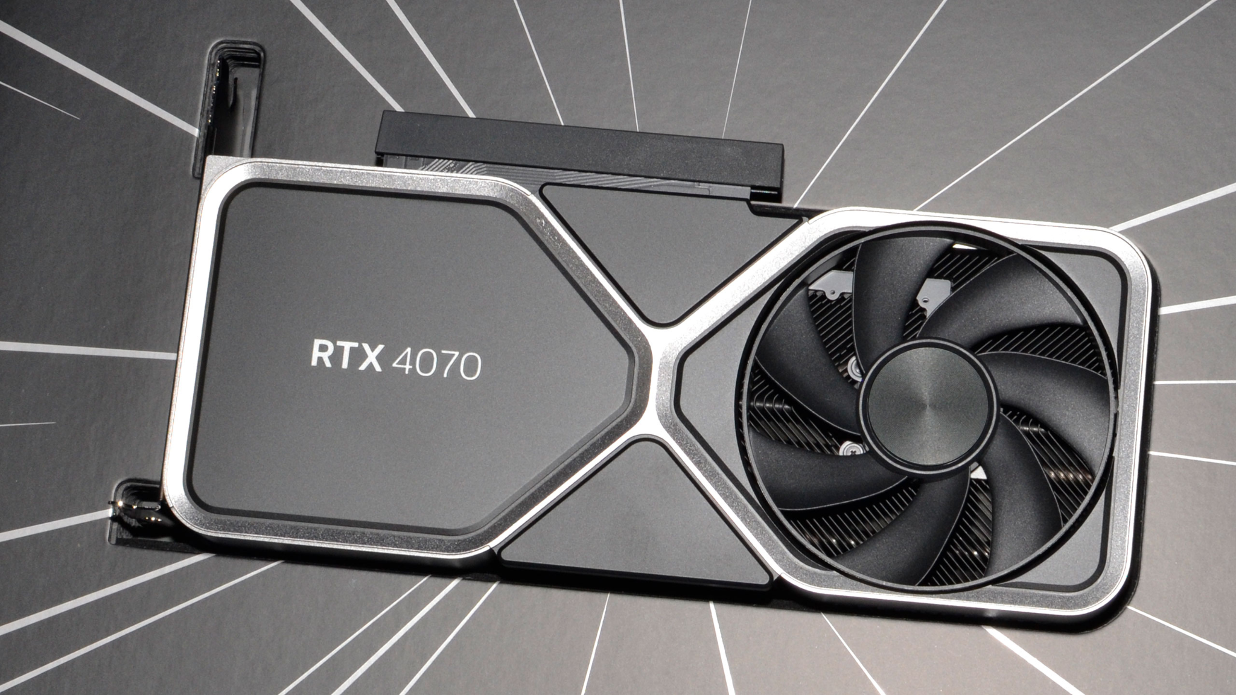

A Graphics Processing Unit (GPU) enhances image and video processing. It can be:

* Integrated GPU (built into the CPU): Suitable for basic tasks like browsing and office work.
* Dedicated GPU (separate card): Ideal for gaming, video editing, and AI processing.
* Ray tracing and AI capabilities are becoming common in modern GPUs for better graphics rendering.

## 

## 

## 

## 

## 

## **8. Cooling System**

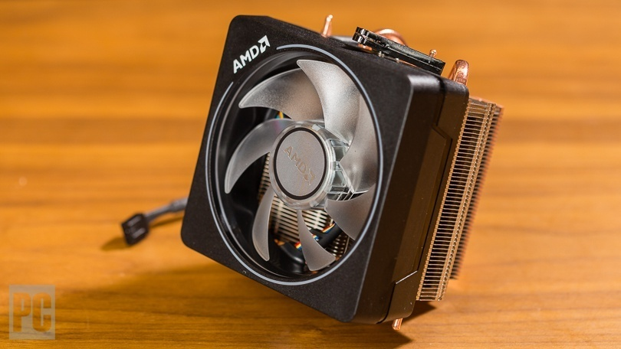

Cooling is necessary to prevent overheating and ensure stable performance. Common methods include:

* Air Cooling: Fans dissipate heat from components.
* Liquid Cooling: More efficient but costlier solution for high-performance systems.
* Thermal Paste: Applied between the CPU/GPU and heat sink for better heat dissipation.

## 

## 

## 

## 

## 

## **9.Bus Slots**

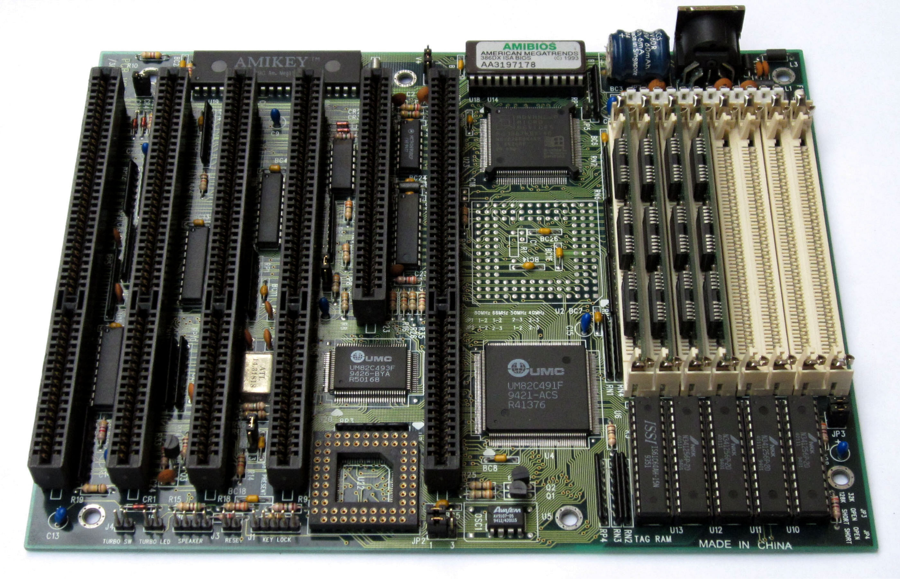

Bus slots refer to designated time intervals allocated for buses to arrive, pick up, and drop off passengers at a specific stop or terminal. These slots help regulate bus schedules, reduce congestion, and ensure smooth transportation operations. They are commonly used in public transit systems, school buses, and intercity bus services to maintain punctuality and efficiency.

**10.Interfacing Ports**

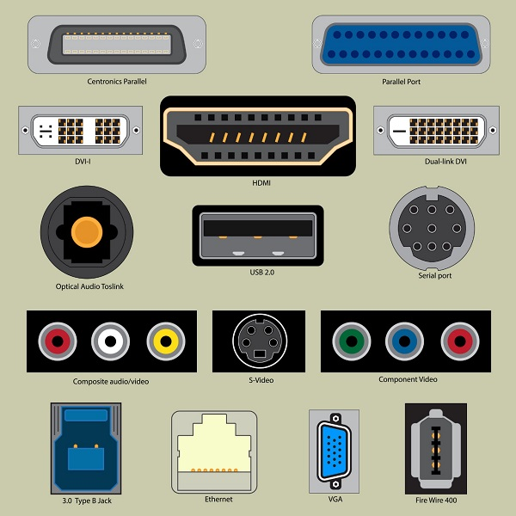

Interfacing ports are physical or virtual connection points that enable communication between different devices, systems, or components. They facilitate data transfer, signal exchange, and power delivery in computing, networking, and embedded systems. Common examples include:

* USB
* HDMI
* Ethernet
* Serial ports

**11.Daughter Cards**

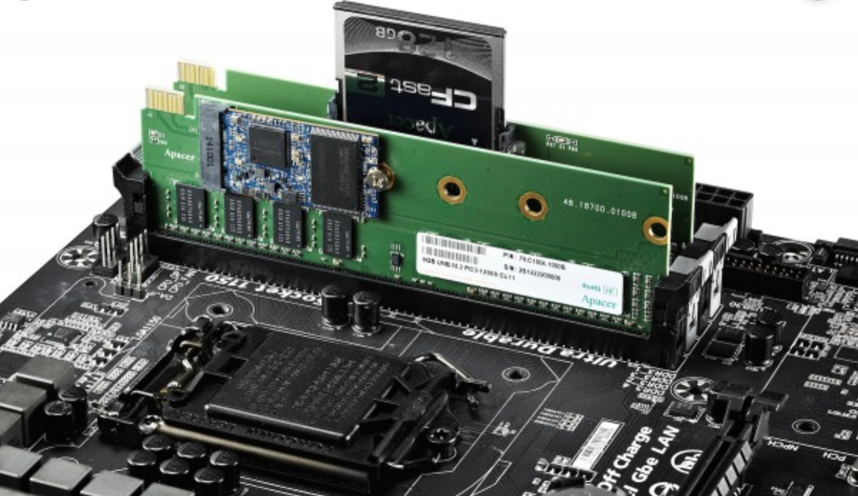

Daughter cards are secondary circuit boards that connect to a main motherboard or primary PCB to expand functionality or add specialized features. They are commonly used in computing, embedded systems, and industrial applications. Common examples include:

* Graphics cards (GPUs)
* Sound cards
* Network interface cards (NICs)
* RAID controller cards

## **Conclusion**

Understanding hardware components is essential for selecting, assembling, and maintaining computer systems. Each component plays a crucial role in the system's functionality, affecting speed, performance, and reliability. With advancements in technology, new innovations continue to improve efficiency, making modern computers more powerful and versatile.